- Efficient Market Hypothesis (20%)
  - Please explain the three different versions of the efficient market hypothesis (EMH). (5%)
  - Please provide two empirical pieces of evidence against weak EMH. (5%)
  - Please provide empirical evidence against the semi-strong version of EMH, which is different from the two pieces of evidence you provide in (b) (5%)
  - What are the limits to arbitrage argument and why it is crucial for behavioral finance schools to fight against the critics of the rational school? (5%)

- Stock market anomalies (15%)
  - Please describe one stock market “anomaly”, provide an explanation from both rational (EMH) school and behavioral school, and develop a strategy to exploit the anomaly.

- Valuation (25%)
  - Please explain what DCF and relative pricing (please provide the main steps) is (10%)
  - Please compare the advantages and disadvantages of DCF and relative pricing (10%)
  - Please discuss whether paying dividends would help boost firm valuation (5%)

- APT (20%)
In a two-factor financial market, we have known the realized return of three assets A, B, and C as follows:
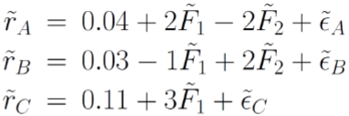
If an asset D has a loading of 4 on the factor F₁ and a loading of 3 on the factor F₂, please use two methods to calculate the mean return of D. (10%)

- Fund Managers (10%)
  - Do you think fund managers can outperform the stock market index return in China? Please provide your thoughts and evidence.

- Behavioral Finance (10%)
  - Please describe two behavioral biases of individual investors in the stock market. Please discuss the phenomenon, explain why it is a bias, and provide the psychological explanation for the bias.

